A Gift for You
Dear {Recipient},
You are receiving a gift of Judean Gold Honey- fresh, 100% pure, raw, unheated, unfiltered Kosher honey direct from the Land of Milk and Honey.
Greeting Line 1
Greeting Line 2
Greeting Line 3
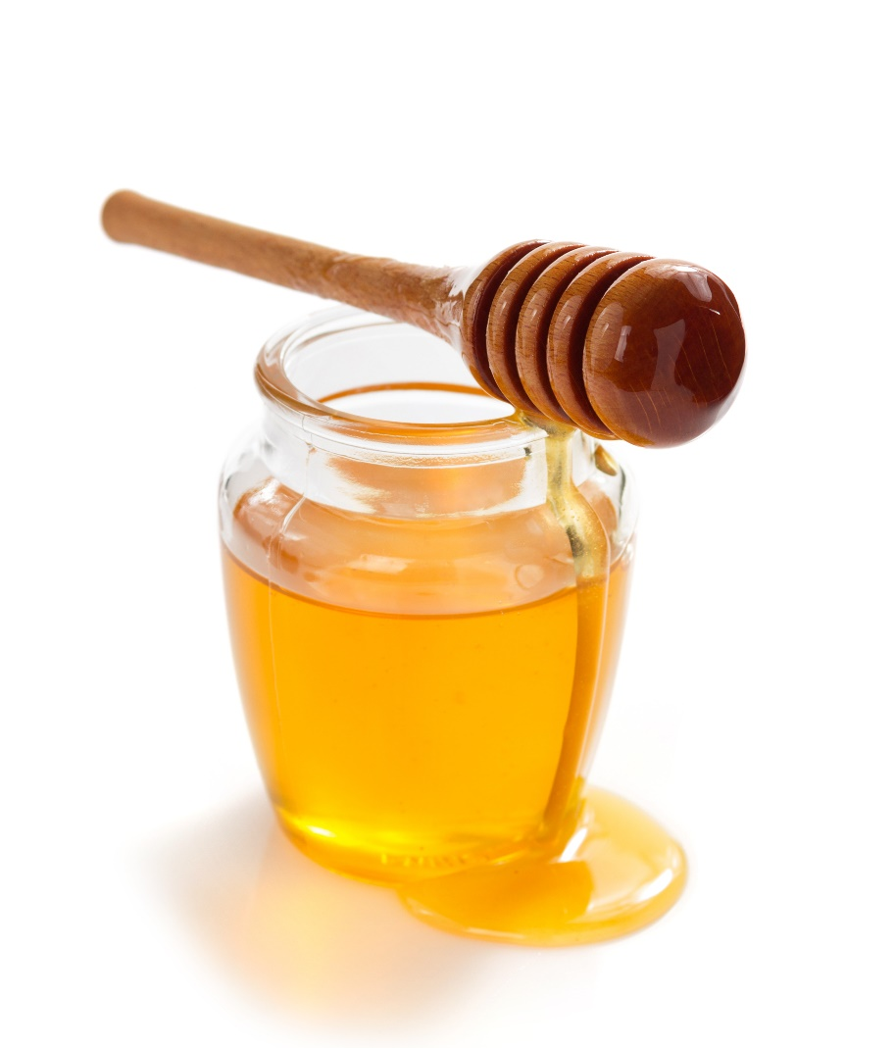
From Line 1
From Line 2

Judean Gold
1-888-688-2582
www.judeangold.com
honeymaster@judeangold.com

